**4B OS Lab-05 Assignment**

# **Muhammad Danish | cs182019 | 4B**

**CODE OUTPUT SCREENSHOTS:**

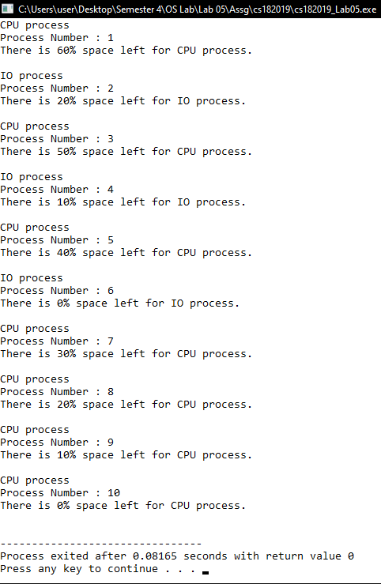

**CODE SCREENSHOTS:**

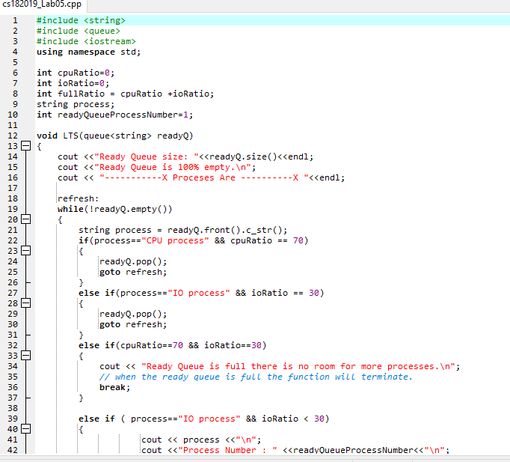

Continued ……

